Advanced Instructional Design
Dennis Adams
Walden University
Dr. Desiree De Priest
EIDT-6110-1
June 22, 2014
Implementation and Evaluation Report

Module Overview and Description

This module was designed for adult learners learning English as their second language. At this beginning level the module introduces them to the alphabet, vowels, numbers, and informal greetings in American English. It is assumed that the adult learner has no formal training in English.

Description of Implementation
Every day for four days one learner completed one hour on instruction along with a pre-test and post-test and interaction with the facilitator after the post test. All work was done on my personal laptop and all observations were made by myself.

Analysis of Evaluation Data
The scores for Students A-D show a progress of 34%, 44%, 38% and 26% respectively.
See chart below.
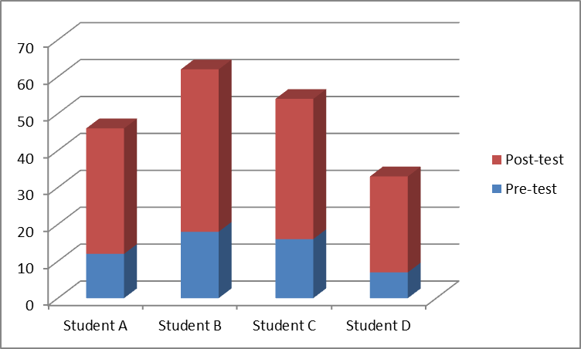
There was definitely a transfer of knowledge to each individual. Due to the size of the population for the data it is not possible to make any calculations that are meaningful. A passing grade of 100% is necessary to continue on to the next module. This data does not reflect the part of the module concerning informal greetings, only alphabet and numbers.
Proposed Revisions and Key Points
During the implementation of the module, observations and data that were gathered were key factors into the revisions in the program as a whole.
- The module should be integrated with a facilitator to provide guidance and content interaction to motivate the student.
- More video should be inserted as learning tools within the module.
- Study materials should be given to each student for time away from class
- Introduction video on use of the computer and navigation of the module.
Summary
The execution of the module went well with no problems. Fortunately by observing the students and how they used the module provided information needed to make changes to make the module more effective. All students left the instruction with a desire to continue and learn more.

